1. **Performance Evaluation and Optimization:**
   * Analyze the results of the implemented models using various evaluation metrics.
   * Optimize the model architecture and parameters to achieve state-of-the-art performance in sleep stage classification.
2. **Documentation and Reporting:**
   * Document the research process, experimental setups, and results.
   * Prepare a comprehensive report summarizing the findings and contributions of the internship project.

By the end of this internship, the intern will have developed a robust understanding of attention-based deep learning approaches for biomedical signal processing and will have contributed to the advancement of automatic sleep stage classification techniques. This experience will equip the intern with valuable skills and knowledge applicable to both academic research and industry applications in the field of neural engineering and rehabilitation.

**1.2 About the internship**

This internship offers a unique opportunity to dive into the cutting-edge field of biomedical signal processing, specifically focusing on sleep stage classification using single-channel EEG data. The foundation of this internship is based on the innovative research paper, "An Attention-Based Deep Learning Approach for Sleep Stage Classification with Single-Channel EEG." As an intern, you will be immersed in the study and practical application of advanced deep learning techniques to solve real-world problems in sleep research.

During this internship, you will gain hands-on experience with the AttnSleep model, an advanced deep learning architecture designed to address the challenges of sleep stage classification. The AttnSleep model combines several sophisticated components, including a multi-resolution convolutional neural network (MRCNN) for feature extraction, an adaptive feature recalibration (AFR) module to enhance feature quality, and a temporal context encoder (TCE) employing multi-head attention mechanisms to capture long-term dependencies in EEG data. You will have the opportunity to implement and experiment with these components, deepening your understanding of their functions and interactions.

A significant part of the internship will involve addressing the issue of data imbalance, a common challenge in sleep stage classification. You will explore and implement class-aware cost-sensitive loss functions and oversampling techniques to ensure the model performs robustly across all classes. Through these activities, you will develop valuable skills in handling imbalanced datasets and optimizing machine learning models for real-world applications.

The internship will also include a comprehensive evaluation phase, where you will assess the performance of the AttnSleep model using various metrics such as accuracy, F1-score, Cohen Kappa, and G-mean. You will conduct extensive experiments on public EEG datasets like Sleep-EDF-20, Sleep-EDF-78, and the Sleep Heart Health Study (SHHS) to benchmark the model's performance against state-of-the-art methods. Additionally, ablation studies will help you understand the contribution of each component to the overall model performance, and sensitivity analyses will ensure the model's stability under different conditions.

Documentation and reporting are crucial aspects of this internship. You will meticulously document your research process, experimental setups, and results, culminating in a comprehensive report that summarizes your findings and contributions. This report will not only serve as a valuable resource for your academic and professional portfolio but also contribute to the broader research community.

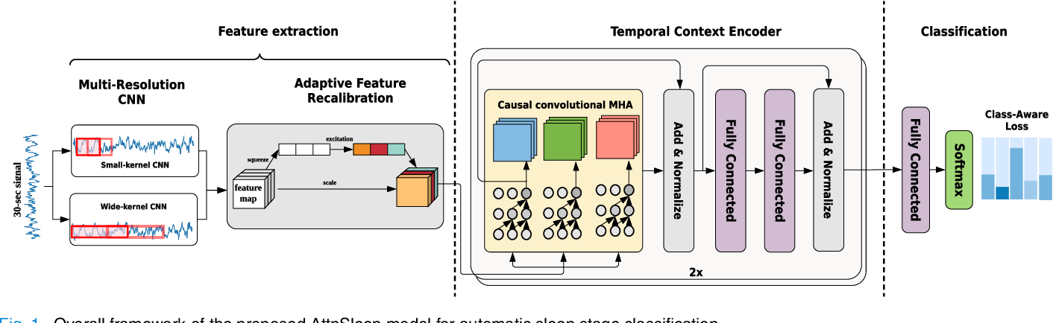Figure 1.1 describes about the basic architecture of the model that is used where, by the end of this internship, you will have developed a robust understanding of attention-based deep learning approaches for biomedical signal processing and gained practical experience in implementing and optimizing complex machine learning models.

**Figure 1.1: Basic architecture of the model**

This experience will prepare you for future roles in both academia and industry, equipping you with the skills and knowledge to tackle challenging problems in neural engineering and rehabilitation. Sleep stage classification is essential for diagnosing and treating sleep disorders, traditionally performed through polysomnography (PSG) involving multiple physiological signals. This study focuses on using only single-channel electroencephalogram (EEG) data, making the process more accessible and less intrusive. The proposed approach utilizes a deep neural network incorporating attention mechanisms to emphasize the most relevant parts of the EEG signal, enhancing the model's ability to differentiate between various sleep stages.

The attention mechanism dynamically weighs the importance of different segments of the EEG data, allowing the model to focus on critical features associated with different sleep stages. This approach not only simplifies the data acquisition process but also improves the model's interpretability and accuracy. The study demonstrates the model's efficacy by comparing its performance against traditional methods and other deep learning models, showing superior accuracy and robustness in classifying sleep stages.

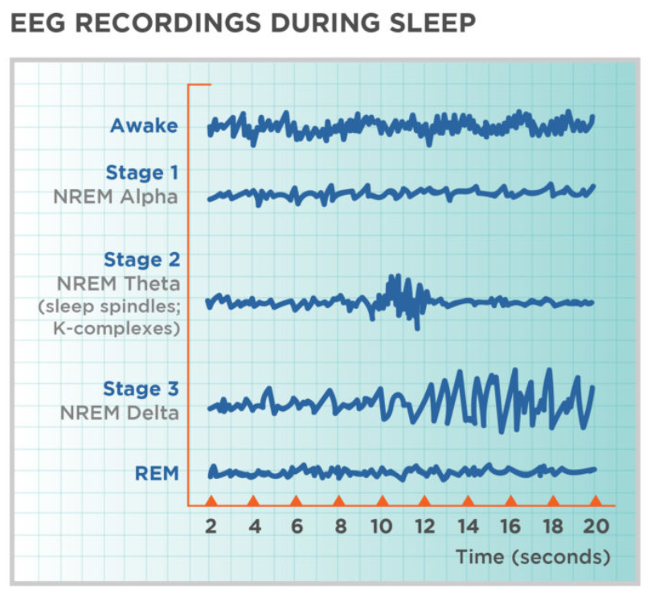By reducing the complexity of data requirements and improving classification performance, this attention-based deep learning approach offers significant potential for advancing sleep medicine. It could facilitate the development of more efficient and user-friendly sleep monitoring devices, making accurate sleep stage classification more widely accessible as portraited in Figure 1.2. This advancement holds promise for better understanding and managing sleep disorders, ultimately contributing to improved health and well-being.

**Figure 1.2: EEG Recording during sleep**